Software Requirements Specification

Office of Dean Students

Prepared by:

**Rahul Jain- 2016197**

**Pratyush Garg- 2016190**

**Somya Jain- 2016265**

**18 April 2019**

**Table of Contents**

**Table of Contents ii**

**Revision History ii**

**1. Introduction 1**

1.1 Purpose 1

1.2 Scope of Project 1

1.3 Document Convention 1

1.4 Intended Audience and Reading Suggestions 1

1.5 References 1

**2. Overall Description 2**

2.1 Product Perspective 2

2.2 Product Functions(Functional Requirements) 2

2.3 User Classes and Characteristics 2

2.4 Operating Environment 2

2.5 Design and Implementation Constraints 2

2.7 Assumptions and Dependencies 2

**3. System Features(Functional Requirements) 4**

**4. Other Nonfunctional Requirements 4**

4.1 Performance Requirements 4

4.2 Safety Requirements 4

4.3 Security Requirements 4

4.4 Software Quality Attributes 5

**Revision History**

|  |  |  |  |
| --- | --- | --- | --- |
| **Name** | **Date** | **Reason For Changes** | **Version** |
| Rahul Jain | 28 Feb 2019 | Use cases refined and added |  |
| Rahul Jain | 18 Apr 2019 | Use cases which are handled by other modules are removed from the use cases. | v0.1 |

# Introduction

## Purpose

The aim of the document is to gather and analyze and give an in-depth insight of the complete Dean Students System of IIITDM Jabalpur. It will define the users and functionality of the Software. The software will try to cater all the functional requirements of the Student Affairs Office.

Also, we shall predict and sort out how we hope this product will be used in order to gain a better understanding of the Software, outline concepts that may be developed later, and document ideas that are being considered, but may be discarded as the product develops. This document describes the project's target audience and its user interface, hardware and software requirements. It defines how our client, team and audience see the product and its functionality. Nonetheless, it helps any designer and developer to assist in Software Development Lifecycle (SDLC) processes.

## Scope of Project

The Software System will be Office of Dean Students Portal to make various events and activities of Student Affair Office work easier with various tools. Accessing the information and performing certain activities will be easy using the Software. Software will facilitate various Student Affair Office related activities.

## Document Convention

When writing this SRS for Dean Student Software, the following terminologies are used:

* Web server (WS): Web Server over which all the data and information is stored.
* Database: Database is collection of data of the Institute’s various departments. Access will be given on proper authentication.
* Client: The user of the Software.

## Intended Audience & Reading Suggestions

Intended Audience of the SRS are students (IIITDM Jabalpur as well as outside) and developers, faculties and Staff. It specifically addresses issues of Student Affair Office.

## References

IEEE. IEEE Standard 830-1998 IEEE Recommended Practice for Software Requirements Specifications. IEEE Computer Society, 1998.

# Overall Description

## Product Perspective

Dean of students of office undertakes all the administrative decisions for gymkhana activities, student hostel allotment, and classroom allotment for club activities etc.

There are specifically 2 Actors in the System-Superintendent, Dean of students. Different Activities are performed by different actors.

## Product Functions

Office of Dean Students will provide a number a functions:

⇨ Facilitate the meeting notification to all the office bearers.

⇨ Software will allow to upload the minutes of the meetings.

⇨Software will allow dean to clear all the relevant budget notification from the gymkhana ERP.

⇨ Approval of all the office bearers.

⇨ Approval of all newly formed committees and clubs

⇨ Hostel room allotment to students.

⇨ Booking classrooms for club activities

⇨ Send all the gymkhana notification.

## User Classes and Characteristics

The typical Office of Dean Students user is simply anyone that has access to the Internet and a web browser. It is assumed that the user is familiar enough with a computer to operate the browser, keyboard and mouse and is capable of browsing to, from and within simple websites and literate enough to do basic operations.

## Operating Environment

Operating Environment of the System will be basic Computer with Network Connectivity.

## Design and Implementation Constraints

The Software will be designed in English Language only. Native languages are not supported by software itself, although if the underlying platform allows it, there is no objection by the part of software developers.

## Assumptions and Dependencies

It is assumed that the platform on which the software is operating is working correctly, such as Network connectivity, Operating System, as well as Hardware components such as Hard disk, RAM, processor, network interface card, are functioning as per requirements. Also, it is assumed that the required technology to run the software is present in the system.

# System Features

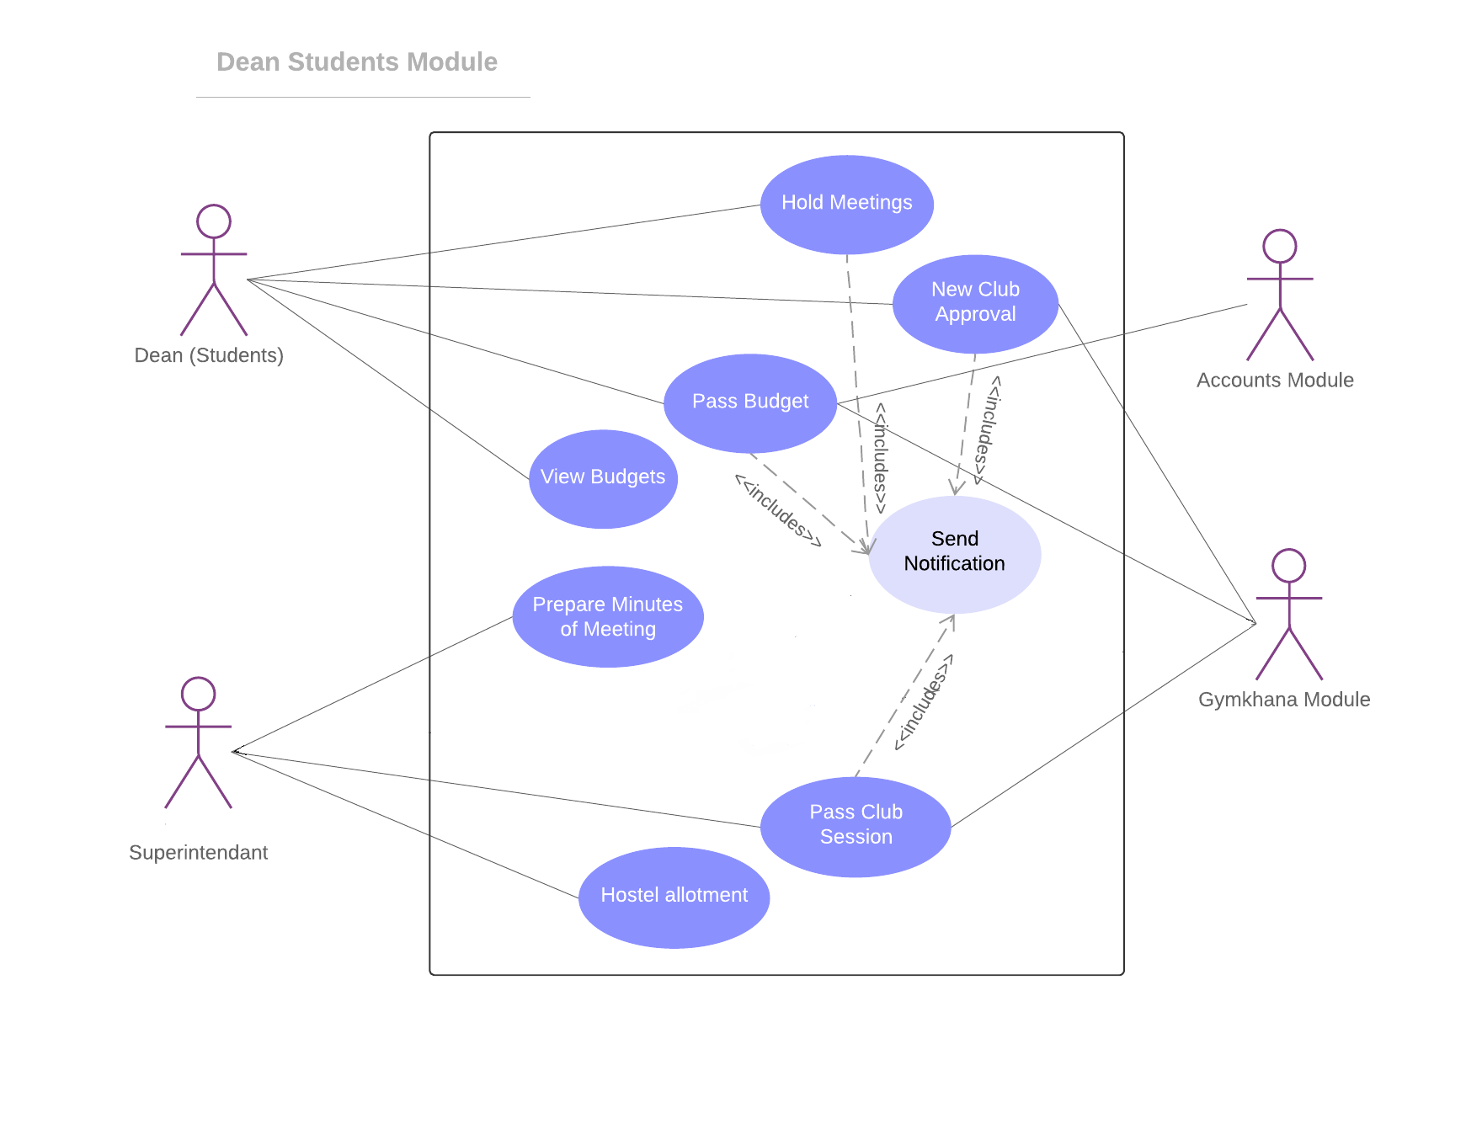

**UseCase#1**

|  |  |  |
| --- | --- | --- |
| UC ID | **UC#1** | |
| Use case Name | **Hold Meetings** | |
| Description | Different meetings related to the Gymkhana(Technical, Cultural, Sports), Budget and Accounts Sections are held. | |
| Actor | Dean Students | |
| Precondition | Dean Students should book the slot(Date, Time, Venue) for the meeting along with the agenda. | |
| Main Flow | 1. | Dean Student books the slot for the Meeting |
| 2. | Notification for the meeting is then passed on to the Superintendent and the Gymkhana. |
|  |  |
| Post Condition | The Minutes and the Schedule of the meeting are fixed and no other  meeting is going to be held in that time.. | |
| Alternate Flow | Resend the notification of meeting if the any of date, time, venue changes. | |
| Sub Flow | **UC#8** | |
| Global Alternate Flow |  |  |

**UseCase#2**

|  |  |  |
| --- | --- | --- |
| UC ID | **UC#2** | |
| Use case Name | **Pass Budgets** | |
| Description | Dean Students is able to accept/reject the budget and then the account section passes it onto the specified clubs. | |
| Actor | Dean Students(Primary), Gymkhana(Secondary), Accounts Section(Secondary) | |
| Precondition | Dean students should be able to see the details of proposed budget. | |
| Main Flow | 1. | The Dean Students must be able to go through the agenda of the meeting |
| 2. | He is given an option to accept or reject the proposed budget. |
| 3. | The Finalized list of the budget is then sent to the accounts section to distribute the budget. |
| Post Condition | The Final Budget is then passed on and no other changes are made to it. | |
| Alternate Flow | In case of insufficient funds, the respective club will be notified to send a request to Superintendent to edit the allotment. | |
| Sub Flow | **UC#8** | |
| Global Alternate Flow |  |  |

**UseCase#3**

|  |  |  |
| --- | --- | --- |
| UC ID | **UC#3** | |
| Use case Name | **New Club Approvals** | |
| Description | Proposal for any new clubs submitted by any student of the institute will be forwarded to Dean Students for approval | |
| Actor | Dean Students(Primary), Gymkhana(Secondary) | |
| Precondition | The proposal should be filled and recorded. | |
| Main Flow | 1. | Proposal will be forwarded to Dean Students from the Gymkhana. |
| 2. | Proposal will be viewed by Dean Students for approval. |
| 3. | If approved it will be passed to Superintendent to issue a notification for it. |
| Post Condition | No objection should be there against the proposal | |
| Alternate Flow | If rejected, proposal will be send back to the Gymkhana for making required changes. | |
| Sub Flow | **UC#8** | |
| Global Alternate Flow |  |  |

**UseCase#4**

|  |  |  |
| --- | --- | --- |
| UC ID | **UC#4** | |
| Use case Name | **View Budgets** | |
| Description | Dean Students can view all the past budgets of Clubs/Fests | |
| Actor | Dean Students(Primary), Gymkhana(Secondary) | |
| Precondition | All the budgets approved in past are recorded in database. | |
| Main Flow | 1. | Dean Students views all the budgets under respective council’s section. |
| 2. | Dean Students views the necessary files attached with each approval. |
| 3. | Then a new budget can be passed/approved with reference to old budgets. |
| Post Condition | All records viewed. | |
| Alternate Flow |  | |
| Sub Flow |  | |
| Global Alternate Flow |  |  |

**UseCase#5**

|  |  |  |
| --- | --- | --- |
| UC ID | **UC#5** | |
| Use case Name | **Prepare minutes of meeting** | |
| Description | The Superintendent gathers the minutes of the particular meeting. | |
| Actor | Superintendent | |
| Precondition | The superintendent must be able to go through the objectives(agenda) of the meeting. | |
| Main Flow | 1. | The Meeting agenda is known and the Approvals taken in the meeting are added to the list |
| 2. | The Minutes are thus gathered by the Superintendent |
| 3. | The next plans to be taken by the committee is also discussed along with the previous meeting minutes |
| Post Condition | The final meeting minutes are thus gathered and passed on to the Dean Students to review. | |
| Alternate Flow |  | |
| Sub Flow | **UC#8** | |
| Global Alternate Flow |  |  |

**UseCase#6**

|  |  |  |
| --- | --- | --- |
| UC ID | **UC#6** | |
| Use case Name | **Hostel allotment** | |
| Description | The Superintendent allots the Hostel Room to the students of the institution | |
| Actor | Superintendent | |
| Precondition | The superintendent must be known of the students arriving the Institution of the different graduation year | |
| Main Flow | 1. | The superintendent is thus given the information of the room needed to the Specific year |
| 2. | Thus the room is allotted to the students(Batch wise) in that particular year |
| 3. | Thus the room allotted is stored as a record |
| Post Condition | The Room allotted is thus given to the students | |
| Alternate Flow |  | |
| Sub Flow | **UC#8** | |
| Global Alternate Flow |  |  |
|  |  |  |

**UseCase#7**

|  |  |  |
| --- | --- | --- |
| UC ID | **UC#7** | |
| Use case Name | **Accept/Reject Club Session** | |
| Description | The Superintendent accepts the club session request and book the room for the club activity | |
| Actor | Superintendent(Primary), Gymkhana(Secondary) | |
| Precondition | Club session request from the Gymkhana | |
| Main Flow | 1. | The Superintendent sees the club session requests |
| 2. | The Superintendent accept the request |
| 3. | Room is allotted by the Superintendent for that specific club activity |
| Post Condition | Thus the notifications regarding the approval or rejection of the club session are passed to the Gymkhana for further process. | |
| Alternate Flow |  | |
| Sub Flow | **UC#8** | |
| Global Alternate Flow |  |  |

**UseCase#8**

|  |  |  |
| --- | --- | --- |
| UC ID | **UC#8** | |
| Use case Name | **Send Notifications** | |
| Description | Send notifications of the specific activity to the desired people. | |
| Actor |  | |
| Precondition | The Superintendent/Dean Students must be aware of the activities that needs to be notified | |
| Main Flow | 1. | The superintendent is thus given the information of the various approvals |
| 2. | Thus hereby is given the authority and thus he is able to send the notifications |
| 3. | the reply mails are thus seen by the superintendent first and then is forwarded to the Dean(S) |
| Post Condition | Thus the Notifications are received to the Students | |
| Alternate Flow |  | |
| Sub Flow |  | |
| Global Alternate Flow |  |  |

# Other Nonfunctional Requirements

## Performance Requirements

The software should be able to run day and night continuously without getting disrupted on its own.

If there is any delay in the connection of the database, Proper Error Message must be displayed.

System should not exit, without informing the user.

## Safety Requirements

Information transmission should be securely transmitted to server without any changes in information.

## Security Requirements

The main security concern is for User account (Gymkhana Office Bearers and Administrator) hence proper login mechanism should be used to avoid hacking. The password must be kept in proper encrypted format. The software also sends any kind of data to other machine than the user by itself unless tampered. The systems back-end servers shall only be accessible to authenticated administrators.

## Software Quality Attributes

The software should be portable so that it can run over multiple platforms. The software should not crash the users machine or the remote server. It sends requests to download web pages. It should not eat excessive bandwidth on network. It should not put extra load on the users’ machine, making user handle to do any other work. The software should be extensible and should be able to get easily used as a component to larger systems. The software should be maintainable and testable easily. The software should be foremost usable and should work as per the software requirement specifications. The software should be intuitive to use and easy to learn.